**Roll No: 412084**

**Prn No: 2019033800126574**

**Name: YAGNIK MOJIDRA**

**“Assignment -3”**

**Github::** <https://github.com/YagnikMojidra/Dot-Net-workspace>

**Question 1::**

**Code::**

// We want to develop a program that can do the following:

// · Prompt the user for input of two integers, which we will call numerator and denominator. For clarity, we are only looking at integers, because this assignment is about rational numbers. A rational number can always be expressed as a quotient of two integers.

// · Calculate the floating point division result (e.g. 10/4 = 2.5).

// · Calculate the quotient and the remainder (e.g. 10/4 = 2 with a remainder of 2 = 2 2/4).

// Your final program should work as in this sample run, and use the same labeled format:

// Please enter the numerator? 14

// Please enter the denominator? 4

// Integer division result = 3 with a remainder 2

// Floating point division result = 3.5

// The result as a mixed fraction is 3 2/4.

using System;

class Program

{

// Main Method

static public void Main()

{

// this is about first Question

void problem1()

{

Console.WriteLine("Enter the Numerator::");

int a = Convert.ToInt32(Console.ReadLine());

Console.WriteLine("Enter the Denominator::");

int b = Convert.ToInt32(Console.ReadLine());

int c = a / b;

int d = a % b;

Console.WriteLine($"Integer Division Result is= {c} with Reminder is {d}");

float e = (float)a / (float)b;

Console.WriteLine($"Float point Division Result is= {e}");

Console.WriteLine($"The result as a mixed fraction is={c} {d}/{b}");

}

problem1();

}

}

Output:

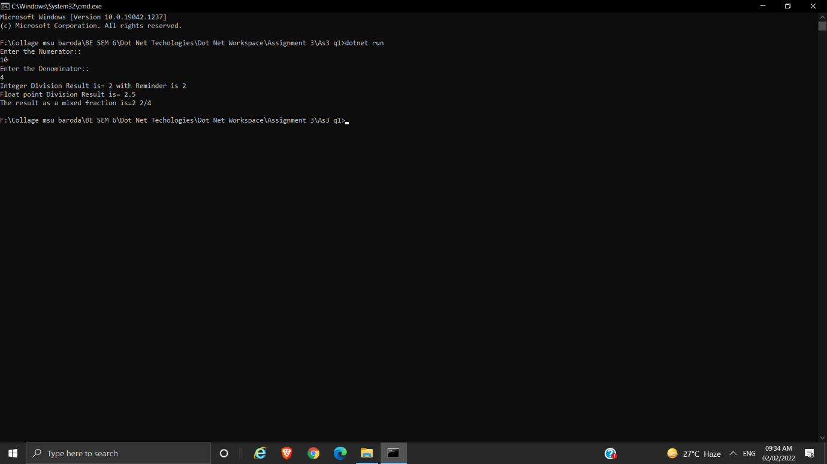

**Question 2::**

**Code::**

using System;

class Problem2Check

{

public static bool isDecl(string m)

{

int x = m.Count();

return m[x - 1] == '.';

}

public static bool isInter(string m)

{

int x = m.Count();

return m[x - 1] == '?';

}

public static bool isExa(string m)

{

int x = m.Count();

return m[x - 1] == '!';

}

}

class As3q2

{

public static void Main()

{

// this is second question part1

void Pro21()

{

Console.WriteLine("This question is first part of second question");

// Label l1=new Label();

Console.WriteLine("Enter the StringName");

String name = Console.ReadLine();

int c = name.Count();

Console.WriteLine($"The String Length is {c}");

}

Pro21();

// this is second question part 2

void Pro22()

{

Console.WriteLine("This question is second part of second question");

Console.WriteLine("Enter the Sentence");

String name = Console.ReadLine();

if (Problem2Check.isDecl(name))

{

Console.WriteLine(" It is Declarative Sentence.");

}

else if (Problem2Check.isInter(name))

{

Console.WriteLine(" It is Interrogatory Sentence.");

}

else if (Problem2Check.isExa(name))

{

Console.WriteLine(" It is Exclamation Sentence.");

}

else

{

Console.WriteLine(" It is not a Sentence.");

}

}

Pro22();

// this is second question part 3

void Pro23()

{

Console.WriteLine("This question is third part of second question");

Console.WriteLine("Enter the name (Must having first name and last name)");

String name = Console.ReadLine();

String[] ar = name.Split();

Console.WriteLine($"You have entered name '{ar[1]},{ar[0]}'");

}

Pro23();

// this is second question part 4

void Pro24()

{

Console.WriteLine("This question is Fourth part of second question");

Console.WriteLine("Enter the name :");

String name = Console.ReadLine();

String[] ar = name.Split();

if (ar.Length == 1)

{

Console.WriteLine($"You have entered name : '{ar[0]}' ");

}

else

{

Console.WriteLine($"You have entered name : '{ar[1]}' ");

}

}

Pro24();

}

}

**Output:**

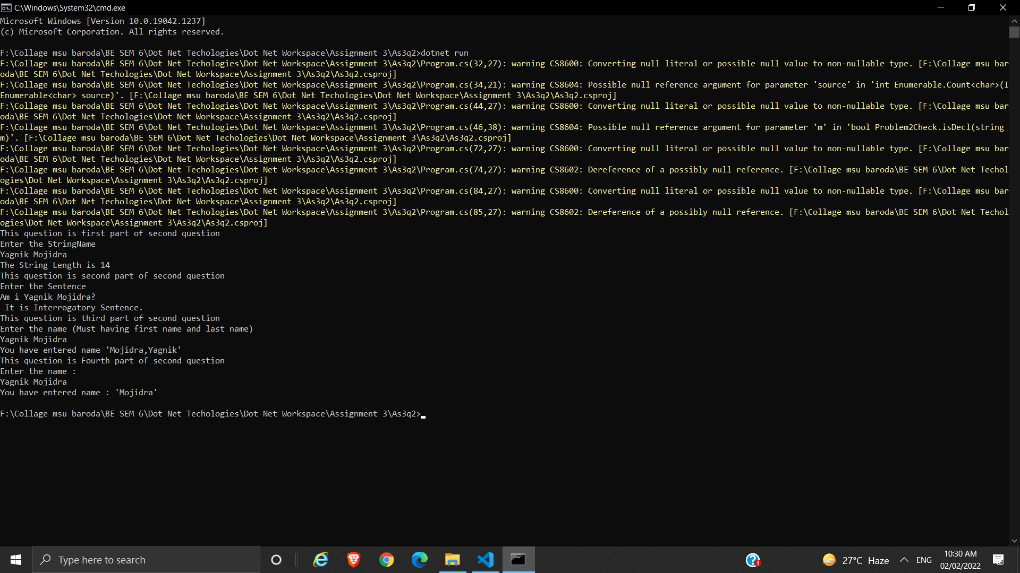

**Question 3::**

**Code::**

[Flags]

public enum Days

{

None = 0b_0000_0000, // 0

Monday = 0b_0000_0001, // 1

Tuesday = 0b_0000_0010, // 2

Wednesday = 0b_0000_0100, // 4

Thursday = 0b_0000_1000, // 8

Friday = 0b_0001_0000, // 16

Saturday = 0b_0010_0000, // 32

Sunday = 0b_0100_0000, // 64

Weekend = Saturday | Sunday

}

public class Flgs

{

public static void Main()

{

Days mettingDays = Days.Monday | Days.Friday | Days.Wednesday;

Console.WriteLine(mettingDays.ToString());

Days workingForHomeDays = Days.Thursday | Days.Friday;

Console.WriteLine($"Join a meeting By Phone on: {mettingDays & workingForHomeDays}");

bool isMeetingOnTuesdays = (mettingDays & workingForHomeDays) == Days.Tuesday;

Console.WriteLine($"Is there a meeting on the Tuesday? {isMeetingOnTuesdays}");

var a = (Days)37;

Console.WriteLine(a.ToString());

}

}

**Output:**

